**Inspection of Incipient Fault of Electrical Equipment Using Deep Convolutional Neural Network based Image Super-Resolution**

Wazir Muhammad

Lecturer Electrical Engineering Department

***Abstract***

With the rapid development of industry and technology, the electrical power system becomes more complex and the electrical equipment becomes more diverse. Defective equipment is often the cause of industrial accidents and electrical injuries, which can result in serious injuries, such as electrocution, burns, and electrical shocks. In some cases, electrical equipment fault may result in death. However, in some special situation, some fault is very small even invisible, such as equipment aging, holes, and cracks, so the detection of these incipient faults is difficult or even impossible. These potential incipient faults become the biggest hidden danger in the electrical equipment and electricity power system. For these reasons, this paper proposes a deep convolutional neural network based image super-resolution reconstruction method for electrical equipment incipient fault to ensure complete detection in electrical equipment, which aims to guarantee the security of electrical power system operation and industry production. Experimental results show that this method can get a state-of-the-art reconstruction effect of incipient fault, so as to provide reliable fault detection of electrical power system.

***Keywords:*** super-resolution, convolutional neural network, incipient fault

***1. Introduction***

In the electrical power system, there is no doubt that the safety of electrical equipment is the basis for ensuring the stability and reliability [1]. Aging and fine lines of electrical equipment components can be characterized as incipient fault of electrical equipment. In power system, fault of electrical equipment components may manifest themselves as abnormal deviations in system behavior and operation. However, due to their very slow evolution, their effects may be confused with noise and uncertainty, which constitutes the characteristic that incipient fault is difficult to detect. Because it is not easy to be discovered, incipient fault is often regarded as precursors in significant accidents. Earlier detected type and exact location of the fault can cause faster detection and repairing of the fault, which is very important for the stable operation of the power system [2]. In recent years, there are many researchers who focus on fault detection of the electrical power system. Huang D et al. developed a transformer fault information pattern recognition and diagnosis model using the objective entropy weight method [3]. Taha I B M et al. designed a conditional probability scheme to inspect transformer incipient fault [4]. And Huang D et al. presented an improved hidden Markov model (HMM) algorithm for fault diagnosis of urban rail transit motors equipment; they also used a back-propagation neural network for multiple faults of complex equipment bearings [5, 6]. However, these methods can only be targeted at minor devices, failing to accurately determine potential incipient fault, which is a limitation in fault detection application. At present, it seems that few works are concerned with the topic of incipient fault detection [7–9]. In view of the above situation, this paper proposes a preprocessing method based on super-resolution (SR) reconstruction, which can helpfully detect the incipient fault by improving the resolution of the electrical equipment image. In this method, a deep network structure is combined with sparse prior information, so as to obtain the high-resolution (HR) version by mapping from low-resolution (LR) input. Finally, the SR reconstruction result of incipient fault can be obtained to improve the subjective visual effect, which can help detect and analyze the electrical equipment fault.

This paper is organized as follows. The basic framework and methods of SR are discussed in Section 2. In Section 3, we evaluate our model on some electrical equipment images containing electrical fault and give a detailed analysis of these results. Finally, Section 4 draws a conclusion.

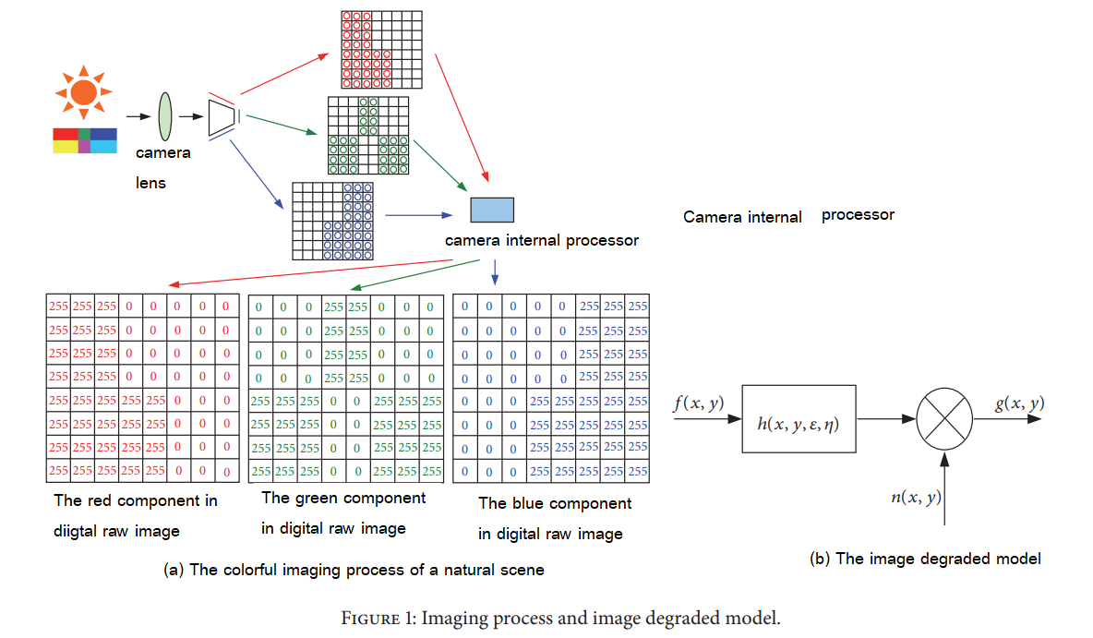

***2. SR Reconstruction Method of Electrical Equipment Incipient Fault***

***2.1. Basic Framework of SR.***

In some special electrical situations where it is difficult to produce HR monitoring video (images), SR reconstruction is an efficient method to improve the resolution of the captured monitoring video (images). SR is a problem of obtaining a HR image from multiple or single LR images [10], which is an inverse problem of imaging process. In imaging process, the LR image is acquired through various imaging devices which are corrupted by noise and other degraded effect [11–13], and the imaging process is shown in Figure 1(a). It is worthwhile to improve the resolution of LR images in some special situations. The observation model of imaging process is mathematized as (1) and shown in Figure 1(b).

where f(x,y) represents the original real HR continuous natural scene, g(x,y) is the output digital LR image, h(, , ) is the point-spread function (PSF), which represents blurring matrices and down sampling matrices, and n(x,y) is the additive noise from different environment and device [14]. From this observation model, SR is an ill-posed inverse problem of reconstructing a HR image from an observed LR image.

Figure 1(a) is the basic illustration of the colorful imaging process of a natural scene, which can obtain R, G, and B channel of an image, respectively, by CCD array. Figure 1(b) is the image degraded model; it corresponds to (1). SR is an inverse process of Figure 1(b), so it is an ill-posed inverse problem which estimates a HR version closed to an original real HR scene

In recent image processing area, the type of SR reconstruction can be divided into single-image SR, single-video SR, and multiple-video SR. Tis paper focuses on singleimage SR; it is more useful in the incipient fault detection of electrical equipment. Single-image SR also can be divided into classical method [15, 16] and learning-based method [17–19]. Figure 2(a) shows the classical multi-frame image to achieve single-image SR; there are 4 LR images with subpixel translation; the complementary information can be fused to reconstruct a HR image with higher resolution. In Figure 2(a), all of the small circulars, rhombuses and triangles represent subpixel different sample points in HR grid, respectively.

The other recently popular method is learning-based SR reconstruction, one of which is illustrated in Figure 2(b) [20]. All of these methods use single-scale or multiscale information to get learning network, so as to achieve HR reconstruction from LR input. In this paper, we adopt the second SR framework to reconstruct detailed information of incipient fault on electrical equipment.

***2.2. SR Reconstruction Method for Incipient Fault Detection.***

The detailed in above order to accurately detect the incipient fault and guarantee safety of electricity power system, improving the resolution of monitoring images of electrical equipment is an effective pathway. A SR reconstruction method is introduced in this paper, which adopt the idea of deep learning network model [21] shown in Figure 3. This model combines the traditional sparse coding model into deep learning so as to obtain HR result, which extends the conventional sparse coding model using several key ideas from deep learning, and complements large learning capacity to improve SR reconstruction performance.

***4. Proposed Network Architecture***

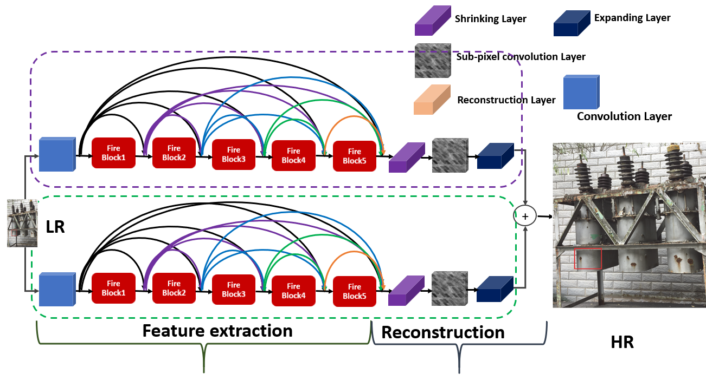

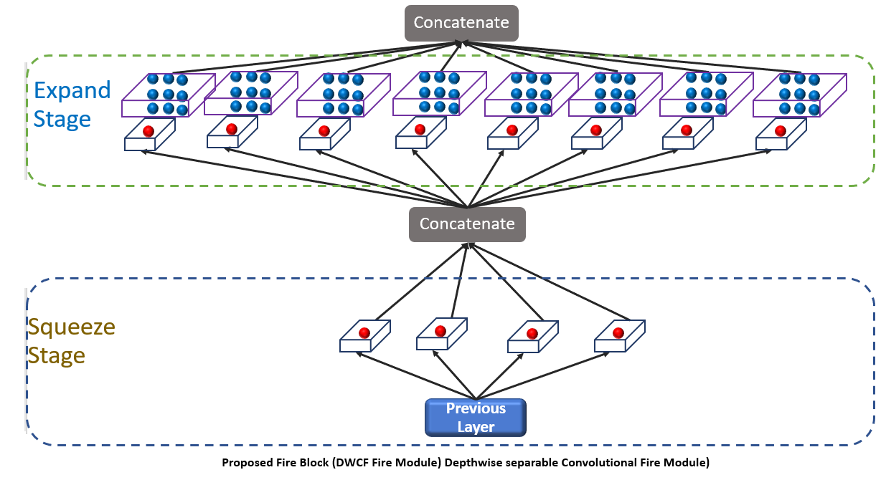

***Experimental Results***

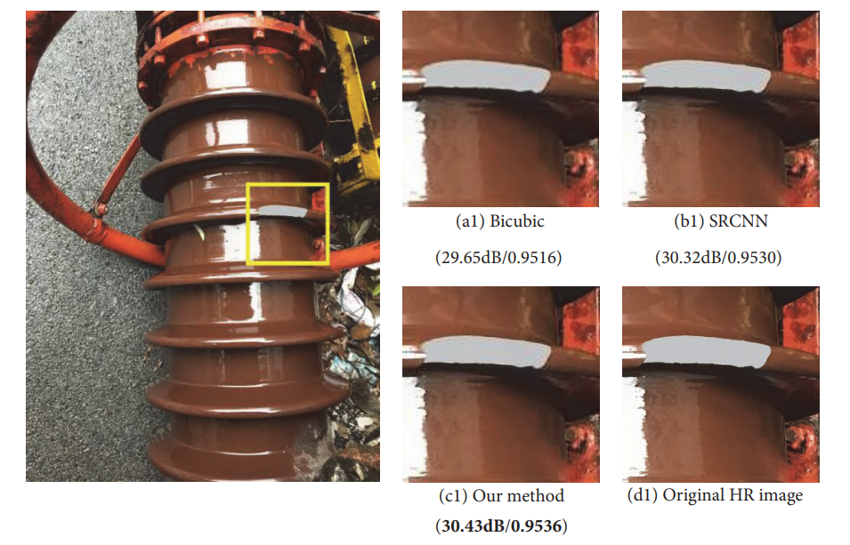

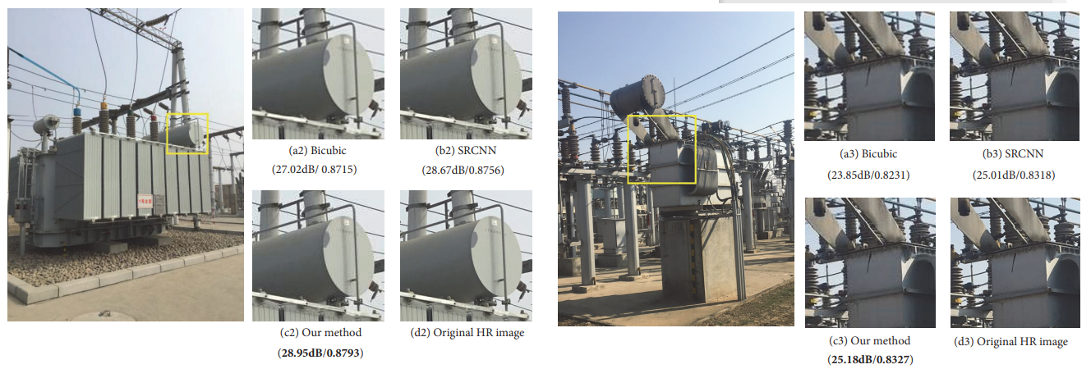

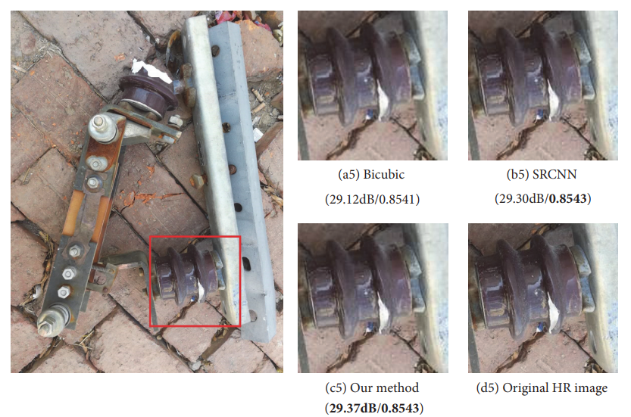

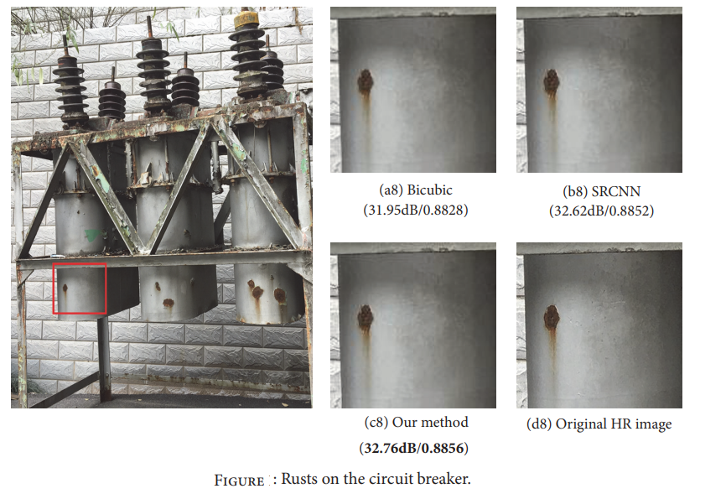

***REFERENCES***

[1] E. Zio and L. R. Golea, “Analyzing the topological, electrical and reliability characteristics of a power transmission system for identifying its critical elements,” Reliab. Eng. Syst. Saf., vol. 101, pp. 67–74, 2012, doi: https://doi.org/10.1016/j.ress.2011.11.009.

[2] N. Ismail, farah hani Nordin, A. Alkahtani, and Z. A. Sharrif, “Detection of the Source of the Incipient Faults Produced by Single Phase Inverter using Feed- Forward Back-Propagation Neural Network,” Indian J. Sci. Technol., vol. 9, Jan. 2017, doi: 10.17485/ijst/2016/v9i48/108325.

[3] D. Huang, C. Chen, G. Sun, and L. Zhao, “Recognition and Diagnosis Method of Objective Entropy Weight for Power Transformer Fault,” Dianli Xitong Zidonghua/Automation of Electric Power Systems, vol. 41, no. 12, pp. 206–211, 2017.

[4] I. B. M. Taha, D.-E. A. Mansour, S. S. M. Ghoneim, and N. I. Elkalashy, “Conditional probability-based interpretation of dissolved gas analysis for transformer incipient faults,” IET Generation, Transmission & Distribution, vol. 11, no. 4, pp. 943– 951, 2017.

[5] D. Huang, L. Ke, X. Chu et al., “Fault diagnosis for the motor drive system of urban transit based on improved hidden markov model,” Microelectronics Reliability, vol. 82, pp. 179–189, 2018.

[6] D.-R. Huang, C.-S. Chen, G.-X. Sun, L. Zhao, and B. Mi, “Linear Discriminant Analysis and Back Propagation Neural Network Cooperative Diagnosis Method for Multiple Faults of Complex Equipment Bearings,” Acta Armamentarii, vol. 38, no. 8, pp. 1649–1657, 2017.

[7] G. Rigatos, P. Siano, and A. Piccolo, “Incipient fault detection for electric power transformers using neural modeling and the local statistical approach to fault diagnosis,” in Proceedings of the IEEE Sensors Applications Symposium, SAS ’12, pp. 32–37, Italy, February 2012.

[8] T. Escobet, V. Puig, J. Quevedo, and D. Garcia, “A methodology for incipient fault detection,” in Proceedings of the IEEE Conference on Control Applications, CCA ’14, pp. 104–109, France, October 2014.

[9] W. Ge, J. Wang, J. Zhou, H. Wu, and Q. Jin, “Incipient fault detection based on fault extraction and residual evaluation,” Industrial & Engineering Chemistry Research, vol. 54, no. 14, pp. 3664–3677, 2015.

[10] K. Zhang, X. Gao, D. Tao, and X. Li, “Single image super-resolution with non-local means and steering kernel regression,” IEEE Transactions on Image Processing, vol. 21, no. 11, pp. 4544–4556, 2012.

[11] I. E. Mourabit, M. E. Rhabi, A. Hakim, A. Laghrib, and E. Moreau, “A new denoising model for multi-frame super-resolution image reconstruction,” Signal Processing, vol. 132, pp. 51– 65, 2017.

[12] P. Purkait and B. Chanda, “Super resolution image reconstruction through Bregman iteration using morphologic regularization,” IEEE Transactions on Image Processing, vol. 21, no. 9, pp. 4029–4039, 2012.

[13] L. Yue, H. Shen, J. Li, Q. Yuan, H. Zhang, and L. Zhang, “Image super-resolution: Te techniques, applications, and future,” Signal Processing, vol. 128, pp. 389–408, 2016.

[14] R. Kolte and A. Arora, “Image super-resolution,” Lap Lambert Academic Publishing, vol. 3, no. 10, pp. 7195–7199, 2013.

[15] A. R. A. Nazren, S. N. Yaakob, R. Ngadiran, M. B. Hisham, and N. M. Waf, “Improving iterative back projection super resolution model via anisotropic difusion edge enhancement,” in Proceedings of the International Conference on Robotics, Automation and Sciences, ICORAS ’16, Malaysia, November 2016.

[16] X. Liu, D. Song, C. Dong et al., “MAP-based image super-resolution reconstruction,” International Journal of Computer and Information Engineering, vol. 27, pp. 208–211, 2008.

[17] W. T. Freeman, T. R. Jones, and E. C. Pasztor, “Example-based super-resolution,” IEEE Computer Graphics and Applications, vol. 22, no. 2, pp. 56–65, 2002.

[18] W. T. Freeman, E. C. Pasztor, and O. T. Carmichael, “Learning low-level vision,” International Journal of Computer Vision, vol. 40, no. 1, pp. 25–47, 2000.

[19] J. Yang, J. Wright, T. S. Huang, and Y. Ma, “Image super-resolution via sparse representation,” IEEE Transactions on Image Processing, vol. 19, no. 11, pp. 2861–2873, 2010.

[20] X. Du, X. Qu, Y. He, and D. Guo, “Single Image Super-Resolution Based on Multi-Scale Competitive Convolutional Neural Network,” Sensors, vol. 18, no. 3, p. 789, 2018.

[21] C. Dong, C. Loy, K. He, and X. Tang, “Learning a deep convolutional network for image super-resolution,” in Computer Vision ECCV, vol. 8692 of Lecture Notes in Computer Science, pp. 184– 199, Springer, New York, NY, USA, 2014.